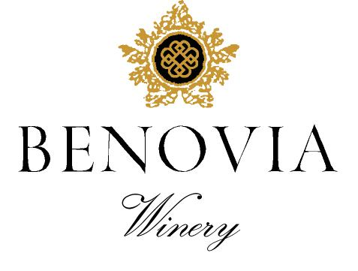
2021 Russian River Valley
Chardonnay
‘La Pommeraie’
Harvest Notes:
The 2021 vintage was welcomed by winemakers and growers after a difficult and challenging prior vintage. Our third drought year in a row, 2021 began with the driest winter on record in the last 127 years and can be best described as a cold start to a warm and fast finish. As a result, our vineyard team implemented several water conservation efforts, including cultivation and repeated early irrigation. With the dry spring conditions, grapevines came out of dormancy early and the mild spring temperatures set a very modest crop. The low yields and drought conditions made for an early and quick harvest of excellent quality.

Winegrower Notes:
This spectacular vineyard sits along Laguna Ridge at the edge of the Green Valley AVA. Meticulously farmed and planted at a very high-density of 2420 vines per acre, the vineyard is planted to Dijon clone 548 and 95. Once a spectacular apple orchard we pay homage to the Martinelli Family and the history of the site by naming the wine ‘La Pommeraie’ – French for apple orchard.

Tasting Notes:
Focused aromas of mandarin orange blossom and Fuyu persimmon are accentuated by candied ginger and mineral notes. Then the vibrancy of the wines’ aroma is matched by its opulent texture and layered flavors of Fuji Apple, lemon custard with a mineral laden finish. Indigenous yeast fermentation in French oak barrels and extended aging of 16 months on lees has produced a wine with exceptional complexity.

Vineyard Sources: |  |  | George Martinelli, Zio Tony Vineyard
Harvest data: |  |  | September 13th
 |  |  | Alcohol 14.5%, pH 3.51, TA 0.60
Fermentation: |  |  | Whole cluster pressed, indigenous yeast fermentation and weekly battonage
Cooperage: |  |  | 16 months in French Oak - 36% new French Oak
Bottling: |  |  | Spring 2023
Cases produced: |  |  | 330 cases
Release Date: |  |  | Fall 2023

Benovia Winery – 3339 Hartman Road Santa Rosa CA 95401 (707) 526-4441 www.benoviawinery.com -

