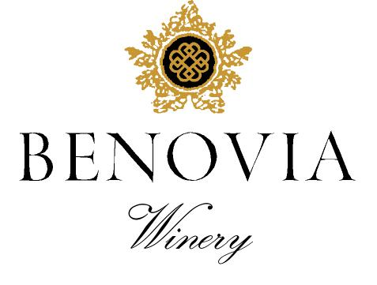
2021 Cohn Vineyard
Sonoma County
Pinot Noir

Harvest Notes:
The 2021 vintage was welcomed by winemakers and growers after a difficult and challenging prior vintage. Our third drought year in a row, 2021 began with the driest winter on record in the last 127 years and can be best described as a cold start to a warm and fast finish. As a result, our vineyard team implemented several water conservation efforts, including cultivation and repeated early irrigation. With the dry spring conditions, grapevines came out of dormancy early and the mild spring temperatures set a very modest crop. The low yields and drought conditions made for an early and quick harvest of excellent quality.

Winegrower Notes:
Planted in 1970, we celebrate the 50th vintage of production from our historic Cohn Vineyard. In California, there are only a handful of Pinot Noir vineyards that have been in existence for 50 years and this is truly a milestone release. Planted to a massale selection of Pinot Noirs (likely Martini 13 and Pommard) our vineyard outdates most other plantings in the Russian River Valley by 20+ years. Farmed organically and with minimal irrigation, these gnarled vines produce small and compact clusters with yields of just over 1 ton per acre. Harvested by hand, at night, the fruit was rigorously hand sorted prior to partial destemming and then berry selected before open-top fermentation.

Tasting Notes:
This flagship wine from our oldest estate vineyard produced a painfully low yield of just over one ton per acre. A medium ruby color is followed by gorgeously intense aromas of meadow herbs, Queen Anne cherries, and intense minerality. Year after year this site has the hallmark of an ethereally floral aromatic quality, with sensual texture and impressive length. We have been very impressed with this milestone 50th vintage from Cohn Vineyard and look forward to how it will age for years to come.

Vineyard Sources: |  |  | Cohn Vineyard
Harvest data: |  |  | September 16th
 |  |  | Alcohol 14.1%, pH 3.76, TA 0.54
Fermentation: |  |  | Cold soaked for 8 days, indigenous yeast fermentation lasted for almost two weeks
Cooperage: |  |  | 48% new French Oak
Bottling: |  |  | Spring 2023
Cases produced: |  |  | 318 cases
Release Date: |  |  | Spring 2024

Benovia Winery – 3339 Hartman Road Santa Rosa CA 95401 (707) 526-4441 www.benoviawinery.com -

