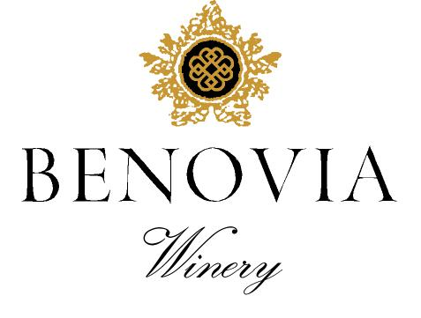
2021 Martaella Vineyard
Russian River Valley
Pinot Noir

Harvest Notes:
The 2021 vintage was welcomed by winemakers and growers after a difficult and challenging prior vintage. Our third drought year in a row, 2021 began with the driest winter on record in the last 127 years and can be best described as a cold start to a warm and fast finish. As a result, our vineyard team implemented several water conservation efforts, including cultivation and repeated early irrigation. With the dry spring conditions, grapevines came out of dormancy early and the mild spring temperatures set a very modest crop. The low yields and drought conditions made for an early and quick harvest of excellent quality.

Winegrower Notes:
This delicious single vineyard Pinot Noir comes from our estate vineyard at the winery that is named in honor of the mothers of Joe Anderson and Mary Dewane. Heirloom Pinot Noir clones were chosen for this intense but delicate Pinot Noir. The grapes are harvested at night and the fruit was rigorously hand sorted prior to partial destemming and then berry selected before open top fermentation. With ideal fruit and stem maturity, we decided for the second year to ferment several clones with ~25 % whole cluster for this vintage.

Tasting Notes:
Deep ruby in color, vine-ripened boysenberries, Bing cherries, and baking spice aromas almost leap from the glass. On the palate the wines juicy mouthfeel is supported by raspberry and ripe plum, building through the mid-palate to the fine grain tannins on the finish. An intriguing blend of power and restraint, this Pinot Noir is both savory and delicately sweet.

Vineyard Sources: |  |  | Martaella Vineyard (Estate)
Harvest data: |  |  | September 20-25 & September 5-7
 |  |  | Alcohol 14.3%, pH 3.57, TA 0.58
Fermentation: |  |  | Cold soaked for 6 days, indigenous yeast fermentation lasted for almost two weeks
Cooperage: |  |  | 40% new French Oak
Bottling: |  |  | Spring 2023
Cases produced: |  |  | 409 cases
Release Date: |  |  | Fall 2023

Benovia Winery – 3339 Hartman Road Santa Rosa CA 95401 (707) 526-4441 www.benoviawinery.com -

