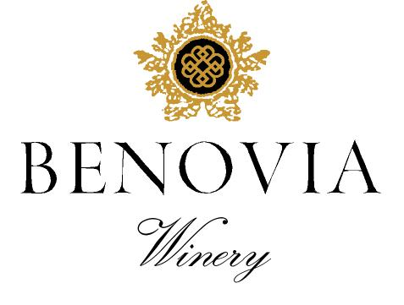
2021 Tilton Hill Vineyard
Sonoma Coast
Pinot Noir

Harvest Notes:
The 2021 vintage was welcomed by winemakers and growers after a difficult and challenging prior vintage. Our third drought year in a row, 2021 began with the driest winter on record in the last 127 years and can be best described as a cold start to a warm and fast finish. As a result, our vineyard team implemented several water conservation efforts, including cultivation and repeated early irrigation. With the dry spring conditions, grapevines came out of dormancy early and the mild spring temperatures set a very modest crop. The low yields and drought conditions made for an early and quick harvest of excellent quality.

Winegrower Notes:
The marvelous single vineyard Pinot Noir and it comes from our coldest estate vineyard. This magnificent property is perched on a ridge top near the town of Freestone, located just a few miles from the Pacific Ocean in the Sonoma Coast AVA. We have planted both heirloom and Dijon clones of Pinot Noir that produce very small clusters that encourage early ripening. The grapes are harvested at night, and then rigorously hand sorted prior to destemming into open top fermenters.

Tasting Notes:
Intense violet in color, this alluring and hedonistic wine has amazing extract and purity of fruit focus. The vibrant fruit aromas of vine ripened raspberry and rich plum harmonize with rose potpourri and notes of forest floor. Heady aromas lead into equally vibrant flavors mixed berry and white pepper. On the palate the juicy red fruits complement the velvet-like texture and spicy finish.

Vineyard Sources: |  |  | Tilton Hill Vineyard (Estate)
Harvest data: |  |  | September 16th – 23rd
 |  |  | Alcohol 14.4%, pH 3.54, TA 0.60
Fermentation: |  |  | Cold soaked for 6 days, indigenous yeast fermentation lasted for almost two weeks
Cooperage: |  |  | 46% new French Oak
Bottling: |  |  | Spring 2023
Cases produced: |  |  | 371 cases
Release Date: |  |  | Fall 2023

Benovia Winery – 3339 Hartman Road Santa Rosa CA 95401 (707) 526-4441 www.benoviawinery.com -

