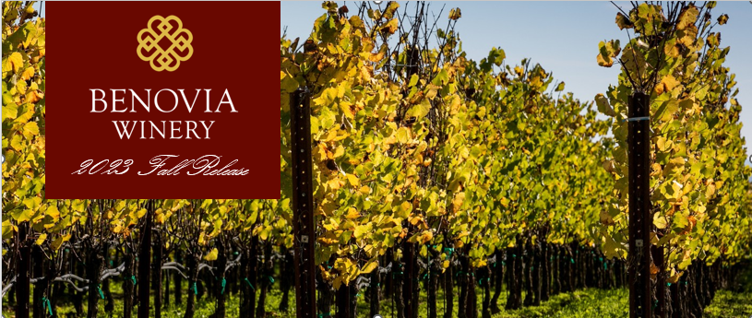
Fall 2023 Release Wines
- 2021 Tilton Hill Chardonnay
- 2021 La Pommeraie Chardonnay
- 2021 Martaella Pinot Noir
- 2021 Three Sisters Pinot Noir
- 2021 Tilton Hill Pinot Noir
- 2021 Bella Una Pinot Noir
- 2021 Clonal Selection 1 Pinot Noir
- 2019 Oakville Cabernet Sauvignon
2021: A Cold Start to a Warm Finish
The 2021 vintage was welcomed by winemakers and growers after a difficult and challenging prior vintage. Our third drought year in a row, 2021 began with the driest winter on record in the last 127 years and can be best described as a cold start to a warm and fast finish. In the spring of 2021, the USDA designated Sonoma County as a D4 or extraordinary drought. Most of our agricultural water is drawn from the Russian River watershed, where our two major lakes were very low: Lake Sonoma 52.4% and Lake Mendocino at 34.2%, respectively.
As a result, our vineyard team implemented several water conservation efforts, including cultivation (discing and spading) and targeted early irrigation. It is a general practice at Benovia to cultivate our soils to preserve sub-surface moisture and promote root growth. In 2021, we fine-tuned our irrigation practices, including irrigation frequency and optimizing water movement to and beyond the active root growth.
With the dry spring conditions, grapevines came out of dormancy early, and the mild spring temperatures set a very modest crop, and in some locations, yields were down between 15-20%. The growing season was void of long and lingering heatwaves, and the light crop ripened early but at a normal rate. The low yields and dry conditions made for an early and quick harvest, with many different varieties ripening at the same time. The resulting wines are very high quality, with intensity, verve, and varietal intensity.
I hope you enjoy these beautiful, elegant and age worthy wines from the 2021 vintage for years to come.
Cheers,
Mike Sullivan, Winemaker & Co-Owner

Fall 2023 Release Tasting Notes

2021 Tilton Hill Chardonnay
The first release for this single vineyard Chardonnay from
our estate vineyard near Freestone. We are very excited
about this inaugural vintage, that we feel captures the
special characteristics of Chardonnay grown in the
Sebastopol hills neighborhood. This wine has exotic
aromas of Chamomile, lemon verbena, green papaya, and
fennel pollen. On the palate the wine is laser focused with
flavors of white grapefruit and Asian Pear.

$65 | Aging potential: 3-5 years | Production: 106 cases
Source: Tilton Hill Estate Vineyard

2021 La Pommeraie Chardonnay
Focused aromas of mandarin orange blossom and Fuyu
persimmon are accentuated by candied ginger and mineral
notes. Then the vibrancy of the wines’ aroma is matched
by its opulent texture and layered flavors of Fuji Apple,
lemon custard with a mineral laden finish. Indigenous
yeast fermentation in French oak barrels and extended
aging of 16 months on lees has produced a wine with
exceptional complexity.

$65 | Aging potential: 4-8 years | Production: 325 cases
Source: Zio Tony Ranch

2021 Martaella Pinot Noir
Deep ruby in color, vine-ripened boysenberries, Bing
cherries, and baking spice aromas almost leap from the
glass. On the palate the wines juicy mouthfeel is supported
by raspberry and ripe plum, building through the midpalate
to the fine grain tannins on the finish. An intriguing
blend of power and restraint, this Pinot Noir is both savory
and delicately sweet.

$75 | Aging potential: 3-7 years | Production: 409 cases
Source: Martaella Estate Vineyard

2021 Tilton Hill Pinot Noir
Intense violet in color, this alluring and hedonistic wine
has amazing extract and purity of fruit focus. The vibrant
fruit aromas of vine ripened raspberry and rich plum
harmonize with rose potpourri and notes of forest floor.
Heady aromas lead into equally vibrant flavors mixed berry
and white pepper. On the palate the juicy red fruits
complement the velvet-like texture and spicy finish.

$75 | Aging potential: 3-7 years | Production: 371 cases
Source: Tilton Hill Estate Vineyard

2021 Clonal Selection 1 Pinot Noir
The 2021 Clonal Selection 1 comes from our Martaella
Estate Vineyard and is a single clone of Pinot Noir called
Dijon 943. This clone is distinctive because of it very small
size (often half the size of other clones) and its dark fruit
character and richness. We barrel fermented 25% percent
of this wine in new French oak barrel. We remove one of
the heads from the barrel, fill it with grapes and then close
it up for fermentation. This barrel fermentation technique
gives us red wines with richness and a distractive opulence.

$80 | Aging potential: 4-7 years | Production: 99 cases
Source: Martaella Estate Vineyard 106 cases

2021 Three Sisters Pinot Noir
Almost ethereal aromatics of vine ripened strawberry and
pomegranate give way to East Asian splices of star anise and
cardamom. Refined aromatics of wild cherries, black tea
and violet floral notes are embraced by baking spices and
cardamom. Essence of plum, raspberry and black cherry
abound on the palate with a smooth texture formed by finegrained
tannins.

$90 | Aging potential: 5-9 years | Production: 72 cases
Source: Three Sisters Vineyard Ft. Ross-Seaview

2021 Bella Una Pinot Noir
Mixed red and black fruit aromas mingle with baking
spices, candied orange peel and sandalwood spice. On the
palate the juicy mouthfeel is supported by the fine grain
tannins on the long and persistent finish. An intriguing
blend of power and restraint, this Pinot Noir is both savory
and delicately spicy. It is drinking great upon release but
will improve with 5-7 years of bottle aging.

$95 | Aging potential: 5-9 years | Production: 219 cases
Source: Tilton Hill Vineyard, La Pommeraie, Martaella
Vineyard

2019 Oakville Cabernet Sauvignon
Our philosophy in making Cabernet Sauvignon was to take
a back seat to the terroir of the place. This 100% Cabernet
Sauvignon is exquisitely rich and decadent, dark floral
aromas with a layered bouquet of blackberry and cassis.
The wine has tremendous richness and the fine-grained
tannin flow seamlessly across the palate, with a lingering
dark chocolate and spice-box finish.

$125 | Aging potential: 5-12 years | Production: 240 cases
Source: Oakville Vineyard

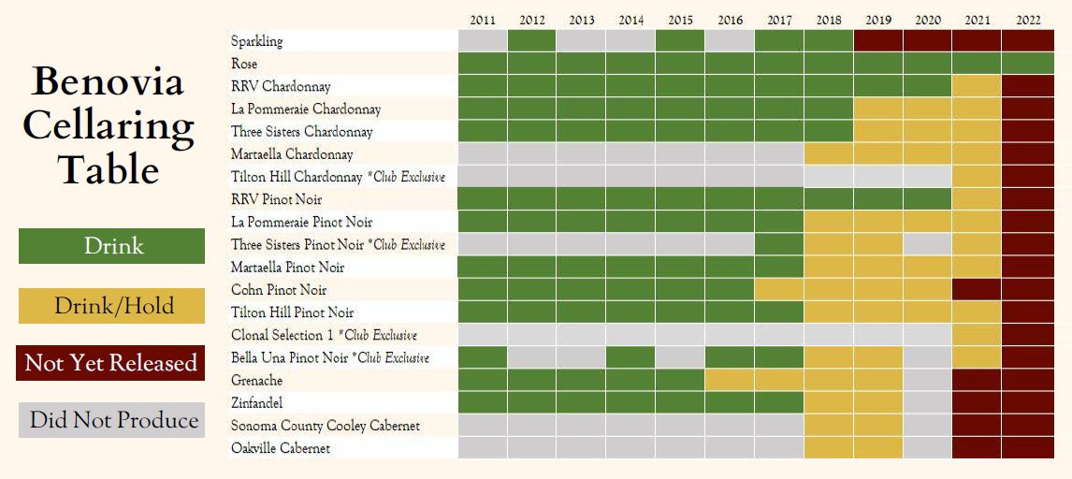
Upcoming Events
Saturday, October 14th:
Cohn Vineyard 50th anniversary
Celebration
Saturday, October 28th:
Fall Release Party at Benovia Winery
Celebrate the fall harvest season with a
tasting of our newly released wines,
paired with bites and lively music.

Saturday, November 4th:
Tucson AZ, Fall Release Event

Sunday November 5th:
Phoenix Fall Release Open
house, invite only

November 10th and 11th
Into Flight Once More Screening
2021 Liberation Pinot Noir Release

Get Ready for the Holidays
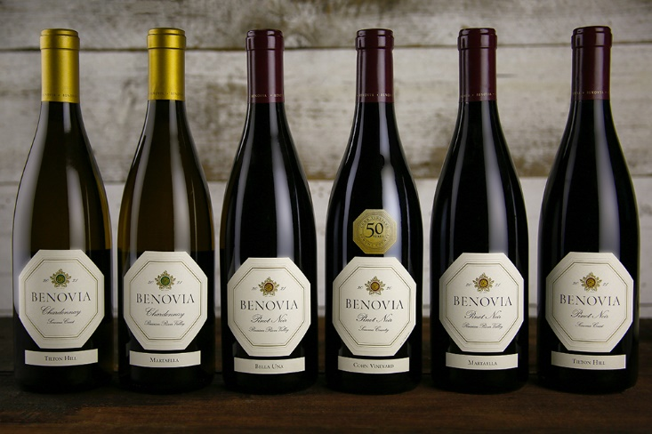
It's never too early to start making your list of friends and family, clients
or co-workers. Show your appreciation with hand-crafted wines from Benovia Winery. Visit our website for holiday gift packs and corporate gifting ideas.

Contact: teambenovia@benovia.com for
assistance with your holiday gifting needs.

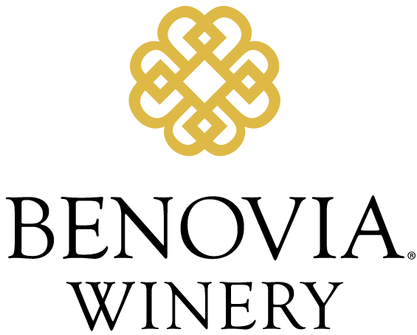
www.benoviawinery.com
707-921-1040
3339 Hartman Road
Santa Rosa, CA 95401

