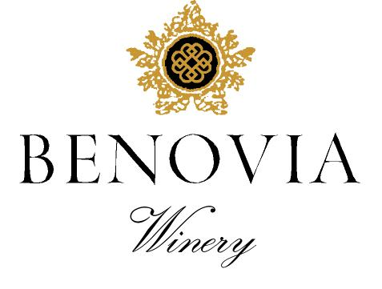
2021 Martaella Vineyard
Russian River Valley
Chardonnay

Harvest Notes:
The 2021 vintage was welcomed by winemakers and growers after a difficult and challenging prior vintage. Our third drought year in a row, 2021 began with the driest winter on record in the last 127 years and can be best described as a cold start to a warm and fast finish. As a result, our vineyard team implemented several water conservation efforts, including cultivation and repeated early irrigation. With the dry spring conditions, grapevines came out of dormancy early and the mild spring temperatures set a very modest crop. The low yields and drought conditions made for an early and quick harvest of excellent quality.

Winegrower Notes:
This is our single vineyard Chardonnay from the Benoiva estate vineyard surrounding the winery is named in honor of the mothers of Joe Anderson and Mary Dewane. We have planted 3 heritage clones of Chardonnay to express the precision and intensity of the varietal. The grapes are harvested, by hand, at night before being whole cluster pressed. After settling overnight, the juice was fermented in small French oak barrels with indigenous yeast and aged for 13 months before bottling without filtration.

Tasting Notes:
Our fourth release of this Martaella Estate Vineyard Chardonnay is bursting with aromas of Meyer Lemon, yellow peach, and ripe summer melon. The multifaceted aromas and vivacious mouth feel are knit together by centered acidity and a long-complex white peach finish. Barrel fermentation and oak aging for 13 months have added hints of candied ginger, and baking spice to a subtle minerality on the finish.

Vineyard Sources: |  |  | Martaella Vineyard (Estate)
Harvest data: |  |  | August 14th and August 19th
 |  |  | Alcohol 14.2%, pH 3.56, TA 0.55
Fermentation: |  |  | Whole Cluster pressed and fermented with indigenous yeast.
Cooperage: |  |  | 38% new French Oak
Bottling: |  |  | March 2023
Cases produced: |  |  | 234 cases
Release Date: |  |  | Fall 2023

Benovia Winery – 3339 Hartman Road Santa Rosa CA 95401 (707) 526-4441 www.benoviawinery.com -

