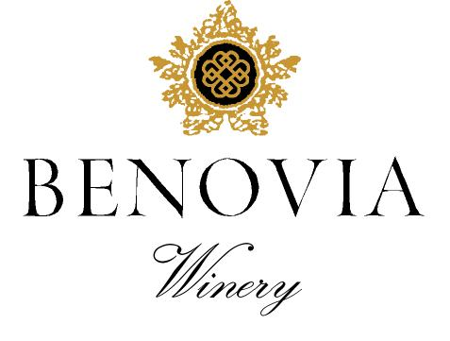
2021 Russian River Valley
Pinot Noir
‘La Pommeraie’

Harvest Notes:
The 2021 vintage was welcomed by winemakers and growers after a difficult and challenging prior vintage. Our third drought year in a row, 2021 began with the driest winter on record in the last 127 years and can be best described as a cold start to a warm and fast finish. As a result, our vineyard team implemented several water conservation efforts, including cultivation and repeated early irrigation. With the dry spring conditions, grapevines came out of dormancy early and the mild spring temperatures set a very modest crop. The low yields and drought conditions made for an early and quick harvest of excellent quality.

Winegrower Notes:
This spectacular vineyard sits along Laguna Ridge at the edge of the Green Valley AVA. Meticulously farmed and planted at a very high-density of 2420 vines per acre, the vineyard is planted to Dijon Pinot Noir clones 777 & 828. Once a spectacular apple orchard we pay homage to the Martinelli Family and the history of the site by naming the wine ‘La Pommeraie’ – French for apple orchard.

Tasting Notes:
This extraordinary single vineyard Pinot Noir gives an immediate impression of depth and concentration in the glass, with remarkably explosive aromas of boysenberry, blueberry, and all spice. This 2021 vintage of La Pommeraie Pinot Noir is unusually elegant and lifted aromas with fine-polished tannins and an exceptionally vibrant but balanced acidity. Delicious upon release, we expect this wine to improve with cellaring for 5-7 years from vintage date.

Vineyard Sources: |  |  | George Martinelli, Zio Tony Vineyard
Harvest data: |  |  | September 1st and 4th
 |  |  | Alcohol 14.5%, pH 3.61, TA 0.58
Fermentation: |  |  | Cold soaked for 6 days, indigenous yeast fermentation
Cooperage: |  |  | 16 months in French Oak 46% new French Oak
Bottling: |  |  | Spring 2023
Cases produced: |  |  | 295 cases
Release Date: |  |  | Spring 2023

Benovia Winery – 3339 Hartman Road Santa Rosa CA 95401 (707) 526-4441 www.benoviawinery.com -

