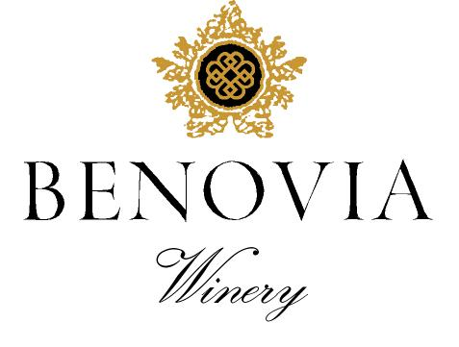
2022 Russian River Valley
Chardonnay

Harvest Notes:
The 2022 vintage began just as the previous vintage had ended, with drier than average conditions and higher than average temperatures. The warm and dry winter coaxed the vines out of dormancy early, where the tender shoots were met with a few nights of freezing temperatures in the spring. Our vineyard manager was busy diligently protecting our vines from frost and resultingly, we had miniscule frost damage. To preserve the sparse soil moister, we cultivated each block early and often and made sure to irrigate appropriately. The continuing drought conditions made for smaller than average yields across all vineyards and varietals. Mild temperatures in May, June and July produced wines with remarkable color, intense fruit, and optimal phenolic ripeness.

Winegrower Notes:
The Chardonnay is now sourced predominantly from our Martaella and Tilton Hill Estate Vineyards. At both sites we have planted Old Wente and Mt. Eden heirloom clones of Chardonnay that retain bright acidity and express beautiful floral and mineral notes. The low-fertility soils and the cool temperatures, in this part of the Russian River Valley, unite to form an ideal place for growing Chardonnay. The fruit was harvested by hand at night then gently whole cluster pressed. After settling overnight, the juice was fermented in barrel with indigenous yeast.

Tasting Notes:
This lively Chardonnay is bursting with aromas of citrus blossom, Jonagold Apple and ripe apricot. The nose is filled green apple and white peach, knit together by balanced acidity and a long-complex finish. Barrel fermentation and oak aging for 13 months have added hints of toasted almond, and spice cake to a subtle minerality on the finish. This dynamic Chardonnay will drink well upon release and will improve with a year or two in bottle.

Vineyard Sources: |  |  | Martaella Estate, Tilton Hill, and Zio Tony
Harvest data: |  |  | August 20th to September 3rd
 |  |  | Alcohol 14.1%, pH 3.47, TA 6.5 g/L
Fermentation: |  |  | Whole Cluster pressed and fermented with indigenous yeast.
Cooperage: |  |  | 32 % new French Oak
Bottling: |  |  | Spring 2024
Cases produced: |  |  | 600 cases
Release Date: |  |  | Spring 2024

Benovia Winery – 3339 Hartman Road Santa Rosa CA 95401 (707) 526-4441 www.benoviawinery.com -

