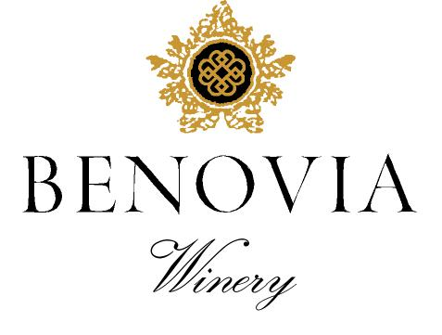
2021 Russian River Valley
Pinot Noir

Harvest Notes:
The 2021 vintage was welcomed by winemakers and growers after a difficult and challenging prior vintage. Our third drought year in a row, 2021 began with the driest winter on record in the last 127 years and can be best described as a cold start to a warm and fast finish. As a result, our vineyard team implemented several water conservation efforts, including cultivation and repeated early irrigation. With the dry spring conditions, grapevines came out of dormancy early and the mild spring temperatures set a very modest crop. The low yields and drought conditions made for an early and quick harvest of excellent quality.

Winegrower Notes:
Through intensively farming each vineyard site, our intent is to maximize the character and individuality of place and we do so utilize the most progressive viticultural techniques. Harvested at night, the fruit was rigorously hand sorted prior to partial destemming and then berry selected before open-top fermentation. This blend is a collection of heirloom clones of Pinot Noir like Calera, Swan, Pommard, Martini, Mt. Eden and Chalone as well as newer French selections like Dijon 777 & 943.

Tasting Notes:
The 2021 vintage provided the raw materials to produce a Russian River Valley Pinot Noir with vibrant fruit and exotic spice aromas and layered texture. Aromas are dominated by red fruit tones of Black Cherry and Boysenberry, while black fruits dominate on the palate. The vibrant aromas expand and give way to red plum, black cherry and complex baking spices. On the palate the wine has integrated acidity and fine tannins that should allow for mid-term cellaring. As always, the wine was bottled without fining or filtration.

Vineyard Sources: |  |  | Martaella, Cohn, Tilton Vineyard, Zio Tony
Harvest data: |  |  | August 17th – September 18th
 |  |  | Alcohol 14.1%, pH 3.63, TA 0.59
Fermentation: |  |  | Cold soaked for 8 days, indigenous yeast fermentation lasted for more than two weeks
Cooperage: |  |  | 44 % new French Oak
Bottling: |  |  | March 2023
Cases produced: |  |  | 1050 cases
Release Date: |  |  | Spring 2023

Benovia Winery – 3339 Hartman Road Santa Rosa CA 95401 (707) 526-4441 www.benoviawinery.com -

